PROJECT: | Flue Gas Desulphurization Project (FGD) with GORETM SO₂ Control System
OWNER: |  |  | HINDALCO INDUSTRIES LIMITED  HINDALCO-RENUSAGAR U5 1 x 80 MW PF CAPTIVE POWER PLANT
HINDALCO CONTRACT No.: HIL/RPD/FGD#5/ON SHORE/01 Dated 01/Nov/2021

Engineering, Procurement, Site Supervision and Commissioning Contractor:  SMARTLùth Solution and Service Pvt. Ltd. |  |  |  | EPCM Contractor:  W. L. GORE & ASSOCIATES (Pacific) Pte, Ltd India Branch
Engineering Associates:
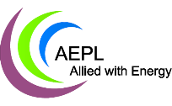

ASTHA ENERGY SERVICE PVT LTD
KOLKATA, WEST BENGAL, INDIA
 |  |  |  | W.L Gore Drg. /Doc. No.: RPDU5.QB.501
FGD DOCUMENT TITLE: FGD & SAC - Project Quality Control Manual (with Job Organization Chart)
Drawing. /Document No: - S21001 - QA01 - 05CPP - 662001 |  |  |  |  | REV.: 0
ISSUED FOR:
☒ INFORMATION
☐ TECH. SPEC. FOR PROCUREMENT
☐ MANUFACTURING
☐ CONSTRUCTION
☐ APPROVAL
☐ AS BUILT

Rev No | Date | Reason of Revision | Prepared by | Reviewed by | Approved by
0 | 19/11/21 | Initial Release | D MUKHOTI | D MUKHOTI | S CHAKRABORTY
Disclaimer:
This document is a property of W. L. GORE & ASSOCIATES (Pacific) Pte, Ltd India Branch/ Smartluth Solution and Service Pvt Ltd. and it may contain trade secrets or privileged, undisclosed or otherwise confidential information. If you have received this document in error, you are hereby notified that any review, copying or distribution of it is strictly prohibited.

PROJECT QUALITY MANUAL

Flue Gas Desulphurization Project (FGD) with GORETM SO₂ Control System
HINDALCO-RENUSAGAR U5 1 x 80 MW PF CAPTIVE POWER PLANT

INDEX
- GENERAL OVERVIEW
- MISSION STATEMENT ON QUALITY
- POLICY IMPLEMENTATION
- MANAGEMENT UNDERSTANDING AND COMMITMENT
  - Quality Assurance Involvement and Applicability
  - Management Commitment
  - Visualization of Quality Culture Demonstrated
- QA DEPARTMENT ROLES AND RESPONSIBILITIES
- Organization Chart
- Vendor Evaluation
- Document Hierarchy

- General Overview
The purpose of a quality manual is to provide the direction through written document to clearly communicate information, and to serve as a framework or roadmap for meeting quality system requirements in the project.
Quality Control and Quality Assurance will be performed according to the standards set forth in this Manual and related document and any additional amendments or addendums thereof.
This Manual outlines the general requirements applicable to all projects / or improvements as well as providing guidance relating to materials, equipment and quality requirements for individual items of work as defined in this Manual and/or the contract documents.
Smartluth employees, contractors, consultants and suppliers related to the project will implement these quality procedures and standards as directed in this Manual.

- MISSION STATEMENT ON QUALITY
It is the mission of Smartluth QA Department that all projects be planned, designed, and constructed with the highest standards of quality. We are committed to the development and implementation of our company wide quality assurance and quality control process solely focused on this mission.
The ultimate goal is to deliver continuous improvements while building long lasting relationships with our customers, based on quality, satisfaction, and personal attention on every project and for every stakeholder.

- POLICY IMPLEMENTATION
Smartluth QA department, Design department, Project department along with the other related Department leaders and the Staff are responsible for the implementation of the Quality Policy.
This manual establishes the policies and procedures guide, coupled with good industry practices to provide a foundation for a quality system. The requirements set forth in the manual shall be applied to, and adhered to, on all projects.
This manual should be used in conjunction with other related procedures, Inspection and Test Plans and other Quality related documents and should often be reviewed for applicability and updated in line with relevant changes in the industry.

- MANAGEMENT UNDERSTANDING AND COMMITMENT

  - Quality Assurance Involvement and Applicability
It is the intent and expectation of Smartluth Management that each and every project will include an appropriate level of QA Department involvement and shall follow the requirements set forth in the manual.

  - Management Commitment
Management will
- Provide adequate resources, including but not limited to personnel, equipment and materials, to implement the policy.
- Support quality objectives
- Lead and participate in quality training.
- Promote quality recognition
- Encourage self-reporting of all quality related issues and/or concerns.

  - Visualization of Quality Culture Demonstrated
Quality posters, lessons learned, and root cause analysis will be posted in the office and project site as applicable.

- QA DEPARTMENT ROLES AND RESPONSIBILITIES

QA/QC Manager:
Lead role of overall QA, QC and HSE function
Direct and advise QC inspectors and Field QHSE advisor
Liaison between Smartluth leadership, QC Inspectors and Field QHSE advisor
Responsible for overall manufacturing and site QC activities
Responsible for updates to Project QA Manual and procedures and Inspection and Test Plans for manufacturing and erection

QC Inspectors:
Carry out Inspection of items / components at vendor premises as per company Quality Procedures, ITPs, drawings and other related documents
Reports Issues, Deficiencies, and Nonconformances related to Quality
Report the result of inspection

Field QHSE advisor:
Lead role of QHSE function at site
Manage QA QC project assignments and Safety issues at site
Daily Point of Contact representing Smartluth and Customer
Primary source for identifying Issues, Deficiencies, Non-conformances related to Quality and Safety

- Organization Chart

Organization chart for the Renusagar FGD project is shown as below

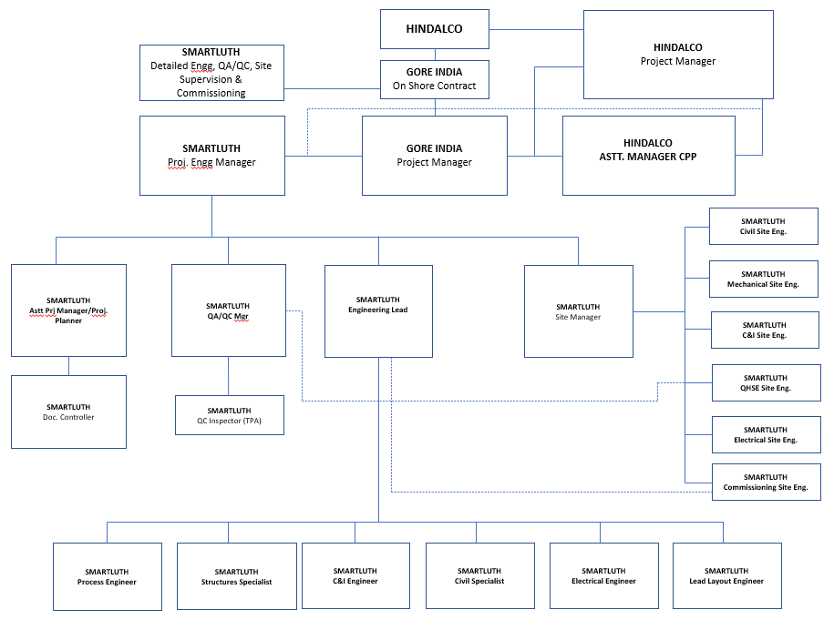

- Vendor Evaluation
All equipment and manufacturing items shall be procured from approved sub vendors. Vendor evaluation shall be carried out by Smartluth after due request from the sub vendor and vendor approval will be provided following successful evaluation.

Customer approved vendors may be considered as approved vendor of Smartluth for the specific project.

- Document Hierarchy

Hierarchy for the project documents pertaining to Quality Assurance and Control is shown below.

CLIENT CONTRACT / ORDER
PROJECT QUALITY MANUAL (PQM)

INSPECTION AND TEST PLAN (ITP)
VENDOR
ERECTION CONTRACTOR
DOCUMENTATION/ CERTIFICATION RECORDS
PROJECT QUALITY PLAN (QCP)

