PROJECT: | Flue Gas Desulphurization Project (FGD) with GORETM SO₂ Control System
OWNER: |  |  | HINDALCO INDUSTRIES LIMITED  HINDALCO-RENUSAGAR U5 1 x 80 MW PF CAPTIVE POWER PLANT
HINDALCO CONTRACT No: HIL/RPD/FGD#5/ON SHORE/01 Dated 01/Nov/2021

Engineering, Procurement, Site Supervision and Commissioning Contractor:  SMARTLùth Solution and Service Pvt. Ltd. |  |  |  | EPCM Contractor:  W. L. GORE & ASSOCIATES (Pacific) Pte, Ltd India Branch
Engineering Associates:


ASTHA ENERGY SERVICE PVT LTD
KOLKATA, WEST BENGAL, INDIA
 |  |  |  | W.L.Gore Drg. No. / Doc. No.: RPDU5.QB.502
FGD DOCUMENT TITLE:
FGD & SAC - Quality Control Plan
Drawing. /Document No: - S21001 – QA01 – 05CPP - 662002 |  |  |  |  | REV.: 0 dated 19.11.2021
ISSUED FOR:
☒ INFORMATION
☐ TECH. SPEC. FOR PROCUREMENT
☐ MANUFACTURING
☐ CONSTRUCTION
☐ APPROVAL
☐ AS BUILT

Rev No | Date | Reason of Revision | Prepared by | Reviewed by | Approved by
0 | 19/11/21 | Initial Release | D MUKHOTI | D MUKHOTI | S CHAKRABORTY
Disclaimer:
This document is a property of W. L. GORE & ASSOCIATES (Pacific) Pte, Ltd India Branch/ Smartluth Solution and Service Pvt Ltd. and it may contain trade secrets or privileged, undisclosed or otherwise confidential information. If you have received this document in error, you are hereby notified that any review, copying or distribution of it is strictly prohibited.

PROJECT QUALITY PLAN

Flue Gas Desulphurization Project (FGD) with GORETM SO₂ Control System

HINDALCO-RENUSAGAR U5 1 x 80 MW PF CAPTIVE POWER PLANT

INDEX

- PURPOSE
- SCOPE
- QUALITY CONTROL OF VENDOR PRODUCT
  - General
  - Inspection and Test Plan
  - Manufacturing and Inspection Schedule
  - Calibration of Measuring Equipment
  - Vendor Internal Inspection
  - Inspection at vendor Premises
  - Material and other Test Certificates and Documents
  - QA/QC WORK FLOW FOR VENDOR PRODUCT
- QUALITY CONTROL AT SITE
  - FIELD QUALITY WORK FLOW

ABBREVIATIONS

WPS – Welding Procedure Specification
PQR – Procedure Qualification Record
WPQ – Welder’s Performance Qualification
NDT – Non-Destructive Testing
ITP – Inspection and Test Plan

- Purpose
Purpose of this procedure is to describe the process for implementation of Quality Control in the project to make sure that products conform to the stipulated requirements.

- Scope
Scope of this document encompasses the total Quality Control aspect in the project. Quality Control process to be implemented for the equipment/ components manufacturing at the vendor premises and the Quality Control process at the erection site.

- Vendor Quality Control

  - General
Vendor shall carry out the raw material, in-process and final inspection as per the technical specification, relevant drawings, acceptance criteria and applicable national / International standards in line with the approved ITP.
Vendor shall follow the defined Quality Program and adhere to the specified requirements at all stages of manufacturing and quality control activities.
Smartluth / Customer reserve the right to verify the quality programme of vendor & its sub- vendors to assure the effectiveness of the programme to meet the intended and specified quality of the product.
Inspection & tests carried out by Smartluth/ customer shall not absolve the responsibility of the vendor to provide acceptable product as per the terms of contract nor shall it preclude subsequent rejection.

  - Inspection and Test Plan
Vendor will submit preliminary ITP for the manufacturing of equipment and also for erection along with the offer, in the specific format as shown in Annexure A and B.
After receipt of purchase order, within a reasonable time, preferably within a week, vendor will submit ITP for manufacturing and for erection of the equipment for approval.
ITP shall specify Inspection and test requirements with due consideration of environment condition, safety, duty cycle, operating conditions, place of installation as applicable for the particular equipment.
Sub-vendor’s manufacturing process shall be included in the ITP as applicable.

  - Manufacturing and inspection schedule

Vendor shall submit manufacturing and inspection schedule indicating stages of manufacturing and tentative inspection dates as per ITP.

  - Calibration of Measuring Equipment
All the measuring equipment used for inspection and testing shall be calibrated. Calibration certificate with traceability to national standards accredited laboratories shall be furnished during inspection.
Calibration certificates for the testing and measuring equipment will be included with the final dossier of inspection /test results.

  - Vendor internal inspection
Vendor shall carryout internal inspection as per the requirements stipulated in the approved ITP, purchase order / technical specification, drawings and any other relevant documents.
All the internal inspection including getting clearance from the Statutory bodies such as IBR, safety authorities etc. are the responsibility of the vendor.
Internal inspection reports including the certificates showing the acceptance of statuary bodies as per the ITP shall be produced to the inspector.
All the inspected raw material / component / equipment shall be duly identified and records shall be maintained to show the status of inspection.
Procedure shall be established to ensure that, product not conforming to the specified requirements, is prevented from inadvertent use or installation. Corrective action report shall be produced along with repaired and reworked product.

  - Inspection at Vendor Premise
When a stage inspection by Smartluth/WL Gore /Customer is envisaged as per the ITP, the vendor will intimate Smartluth/WL Gore/ Customer requesting for inspection in a formal inspection call indicating stage, type of inspection and other detail as per ITP. Inspection call shall reach Samrtluth/WL Gore/Customer around 15 days before the date of Inspection.
Relevant internal Inspection reports, test certificates shall be produced during inspection and will be submitted by vendor as required by the ITP.
Inspector deputed shall carry out receiving Inspection, in-process Inspection and final inspection as specified in the ITP.
During inspection all the previous Internal corrective action report shall be produced along with repaired and reworked product during inspection.
Smartluth/WL Gore/ customer reserve the right to inspect any product at any stage of manufacturing beyond pre-identified stages & hold points of approved ITP.

  - Material and other test certificates and documents

In line with approved ITP, copies of following test certificates, where applicable, shall be submitted by vendor
- Raw Material identification and physical and chemical test certificates
- Stage inspection report as applicable
- Rectification record if applicable
- Control, dimension chart with records of alignment, squareness etc.
- Any applicable document showing component dimensional correctness
- WPS, PQR and WPQ
- Heat treatment and stress relieving chart as per specification
- Non-Destructive Test Report as per respective code
- Hardness test certificate
- Pressure / Leakage test certificates
- Performance test certificates for all characteristic
- Routine /type /calibration /acceptance / special test (Type test etc.) certificates for electrical items
- Certificates from competent authority for the items coming under statutory regulations

  - QA/QC Work Flow for Renusagar Project
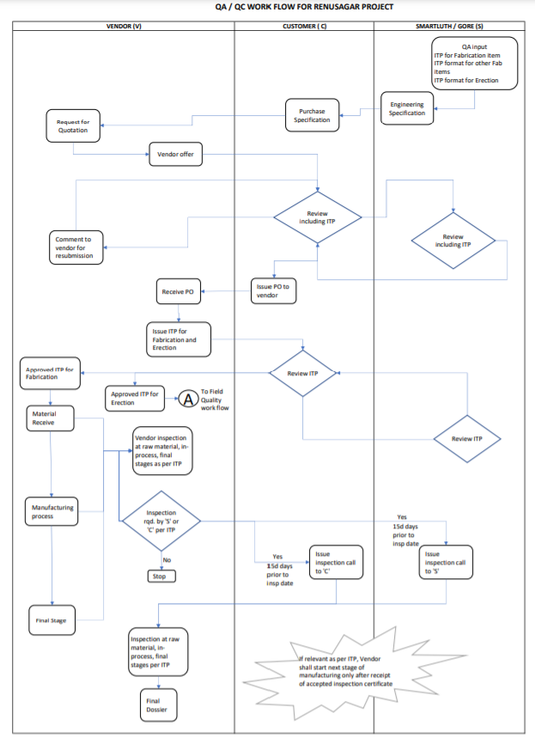

6.9 Vendor’s Responsibility
Vendor shall comply with all the instructions provided by Smartluth/WL Gore/Customer.
Vendor representative who communicates with customer shall mark copy of all quality control / inspection related communication to Smartluth/WL Gore.
Vendor shall provide all instruments, tools, necessary testing and inspection facilities to the Samrtluth appointed inspector for carrying out the inspection
Vendor will ensure that all non-destructive testing shall be witnessed by ASNT level II qualified personnel. All welding will be done as per qualified welding procedure specification (WPS PRQ). All welding shall be carried out by formally qualified welder (WPQ).

- Quality Control at Site
Field QHSE advisor will look after Quality control during site erection activities. He will work as per the guidelines provided by Project QA/QC manager.
Major responsibilities will be to control the overall Quality of Field Work which includes checking whether the approved ITP for erection is being followed in all related erection works. His main area of involvement will be following:
- Overall check that all erection activities are done as per the approved Inspection and Test Plan for erection
- Relevant Inspection and tests are done for civil foundation as per approved ITP
- All welding is done as per the WPS PQR and qualified welders are deputed on the Job. Special attention will be provided in welding for load bearing structural welding, critical piping, alloy steel material and any other critical welding.
- All Non-destructive and other testing and checks are carried out as per the approved ITP for erection.
- All NDT are checked by the Level II qualified personnel, and all tests are carried out by National Approved testing laboratory.
- Attend stage and final inspection as per the Inspection and Test Plan for erection works

  - Field Quality Work Flow
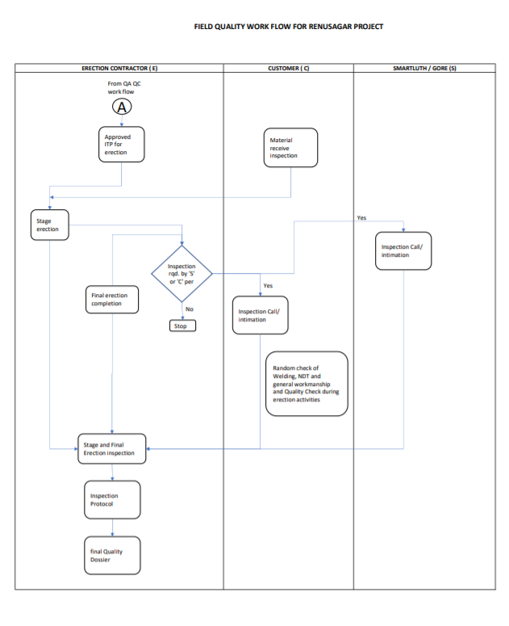

ANNEXURE A
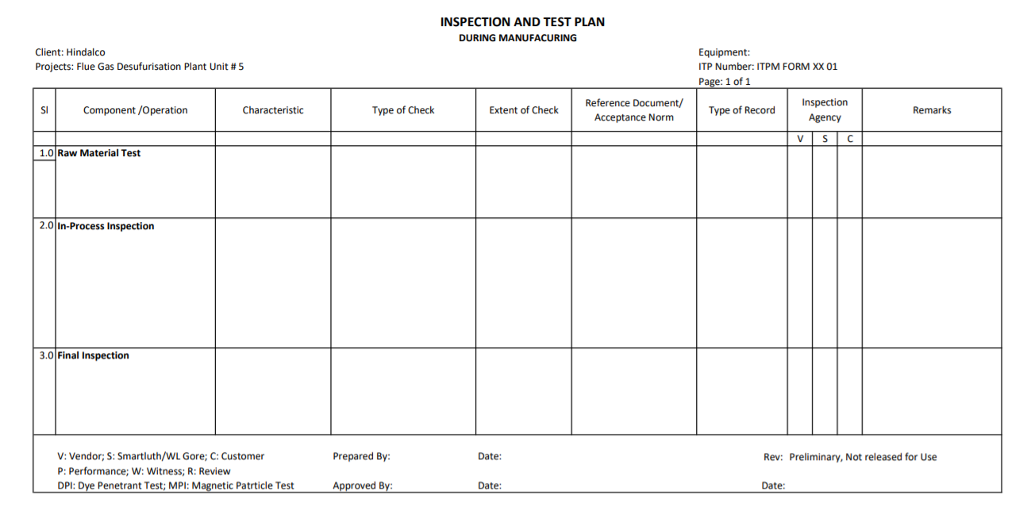

ANNEXURE B
