 |  | Owner:  HINDALCO INDUSTRIES LIMITED  Ahura Centre, 1st Floor, B Wing, Mahakali Caves Road, Andheri (East), Mumbai - 400 093, India
 |  | EPCM Contractor:  W. L. GORE & ASSOCIATES (Pacific) Pte, Ltd. India Branch  703, A-Wing, 215 Atrium, Andheri Kurla Road, Mumbai 400059, India
Nominated Subcontractor - Engineering, Quality Control, Supervision:
SMARTLuth Solution and Service Pvt. Ltd.
Unit No: 503, 5th Floor, ECO Centre, EM-4 Sector-V, Salt Lake City, Kolkata - 700091, India
Hindalco Renusagar U5 1 x 80 MW PF Captive Power Plant

Flue Gas Desulfurization Project (FGD) with GORETM SO₂ Control System

FGD-Technical Specification with Equipment Sizing

)
ISSUED FOR | APPROVAL | INFORMATION | MANUFACTURING | CONSTRUCTION | AS-BUILT

00 | 10/03/2022 | First Submission | S.Das | S.Chakraborty |  | M.Deb
Rev. | Date | Description of revision | Prepared | Checked |  | Approved
Hindalco Renusagar U5 1 x 80 MW PF Captive Power Plant |  |  | Doc. No.: S21001 - TS01 - 05HSD - 227201
Flue Gas Desulfurization Project (FGD) with GORETM SO₂ Control System |  |  | Gore Doc. No.: RPDU5.PG.001 |  | page
FGD-Technical Specification with Equipment Sizing |  |  | GORE Job No.: RPDU5 |  | Rev. : 00
 |  |  | File: FGD- Technical Specification with Equipment Sizing
This document is a property of W.L. GORE & ASSOCIATES (Pacific) Pte, Ltd. and it may contain trade secrets or privileged, undisclosed or otherwise confidential information.
If you have received this document in error, you are hereby notified that any review, copying or distribution of it is strictly prohibited.

Intent:
Flue Gas De-sulphurisation system is introduced on Unit # 5- 1 x 80 MWe of Coal Fired Captive Power Plant at Renusagar Power Division, Sonbhadra, Uttar Pradesh, India, in order to meet the present emission standard, set by MOEF for SO_{x} control, which is < 600 mg/Nm³ at 6 % O₂ dry. The design incorporates provision for attaining SOx level of <200 mg/Nm3 at 6% O₂ dry in future by adding more number of modules.

Design Basis FGD Plant

We have taken cognizance of the anticipated performance and actual performance data at BMCR and 100% TMCR and the above coal analysis provided by RENUSAGAR CPP, namely, Oxygen and Flue Gas temperature at ESP inlet and outlet, and the following gas analysis to derive at the gas flow, temperature, SO_{x} emissions to form the design basis of the FGD system offered.
Flue Gas Duct
Flue Gas Duct | KKS System Code: 50HTA
Flow through ID fan individual discharge | m3/hr | 293335
Flow in m3/s | m3/s | 81.48
Gas temperature | DegC | 148
Dimension of Individual duct selected | m x m | 1.8 x 3.6
There shall be 02 No’s such ducts from individual ID and discharge.
Flow through Common duct to Booster Fan suction*(Flow to match Booster Fan) | m3/s | 163.0
Flow velocity considered | m/s | 12.6
Dimension of BF suction duct selected | m x m | 3.6 x 3.6
Flow through Common duct of Booster Fan discharge | m3/s | 157.4
Flow velocity considered | m/s | 15.5
Diameter of Booster Fan discharge duct selected | m | 3.6
Flow through MCU | m3/s | 157.4
Velocity considered through MCU | m/s | 4.92
Dimension of MCU duct selected (Depth x width x height) | m x m x m | 4 x 8.0 x 15.0

Fan System

Booster Fan | 1 x 100% MCR |  | KKS Identification | 50HSC10AN001
Medium handled | Flue Gas – Analysis (% by Volume, wet): CO₂ – 10.8; O₂ – 6.62; N₂-72.73; Moisture – 9.84.  Flue Gas with dust concentration of 120 mg/Nm3 and SOx level- 1246 mg/Nm³
Type | Centrifugal, Double Suction – Single Outlet, simply supported, backward bladed impeller, Motor driven.  Fan inlet / outlet orientation shall be as per tender layout as per Annexure.
Control of Fan | VFD as primary & RVC or MLD (Pneumatic Actuated) as secondary.
Max. Speed | ~990 RPM
Basic Design Parameter
Cases |  | 100% BMCR(Present) | Fan Design (Present) | 100% BMCR(Future) | Fan Design (Future)
Volume flow | m³/hr. | 5,86,669.00 | 6,45,350.00 | 5,86,669.00 | 6,45,350.00
 |  | Above flow figures are at (-) 25 mmwc and 148 °C
Temperature | °C | 148 | 148 | 148 | 148
Static Pressure at Duct tapping point | mm WC | (-)25 | (-)25 | (-)25 | (-)25
Static Pressure at Fan I/L | mm WC | (-)60 | (-)67 | (-)60 | (-)67
Static Pressure at Fan O/L | mm WC | (+)206 | (+)249 | (+)238 | (+)289
Fan Differential | mm WC | 266 | 316 | 298 | 356
Site Barometric Pr. | mmHg | 736 | 736 | 736 | 736

FGTR (Flue Gas Treatment Reactor)
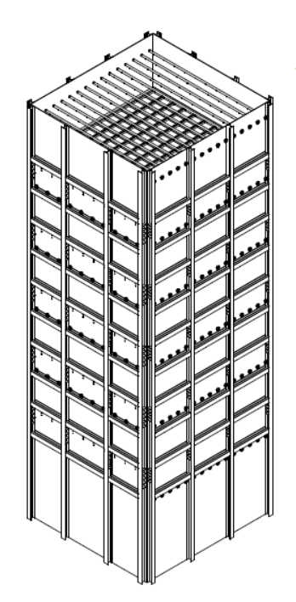
The Flue Gas Treatment Reactor (FGTR) is stacked with layers of GoreTM SPC catalyst modules arranged in 165 stacks with a maximum of 22 vertical layers (inclusive of 5 of catalyst management layers), arranged with a maximum of 5 vertical layers per stack in series , for SOx capture with sufficient space for future addition of layers. The gas velocity through the modules will be designed to a maximum of 2.2 mtr/ sec.

FGTR Module Description | FGTR KKS No: 50HSD10BA001
No. of stacks | Nos | 165
Stack Arrangement | Nos | 11 x 15
No. of layers | Nos | 15 to 22
No of layers for future case | Nos | 27
No. of modules | Nos | 2475 to 3630
Module Weight (Dry) | kg / module | 40
Module Weight (Wet) | kg / module | 80
Module Wet Weight Variability | % | ± 10%

﻿Flue gas flow (before cooling) | Nm³/h, wet | 3,79,591
Flue gas flow (after cooling) | Nm³/h, wet | 4,01,991
Flue gas flow | Am³/h | 5,86,669
Inlet Temperature | °C | 148
Operating Temperature | °C | 53
﻿SO2 inlet conc. | mg/Nm³, dry @6% O2 | 1,590
SO2 inlet conc. | mg/Nm³, dry | 1,446
SO2 inlet conc. | mg/Nm³, wet | 1,246
﻿SO2 outlet conc. | mg/Nm³, dry @6% O2 | 500
SO2 outlet conc. | mg/Nm³, dry | 455
SO2 outlet conc. | mg/Nm³, wet | 392
SO2 Efficiency | % | 65%
﻿GSCS Module Pressure Drop | Pa/layer | 65
GSCS Total Pressure Drop | Pa | 1430
Acid dewpoint | °C | 64

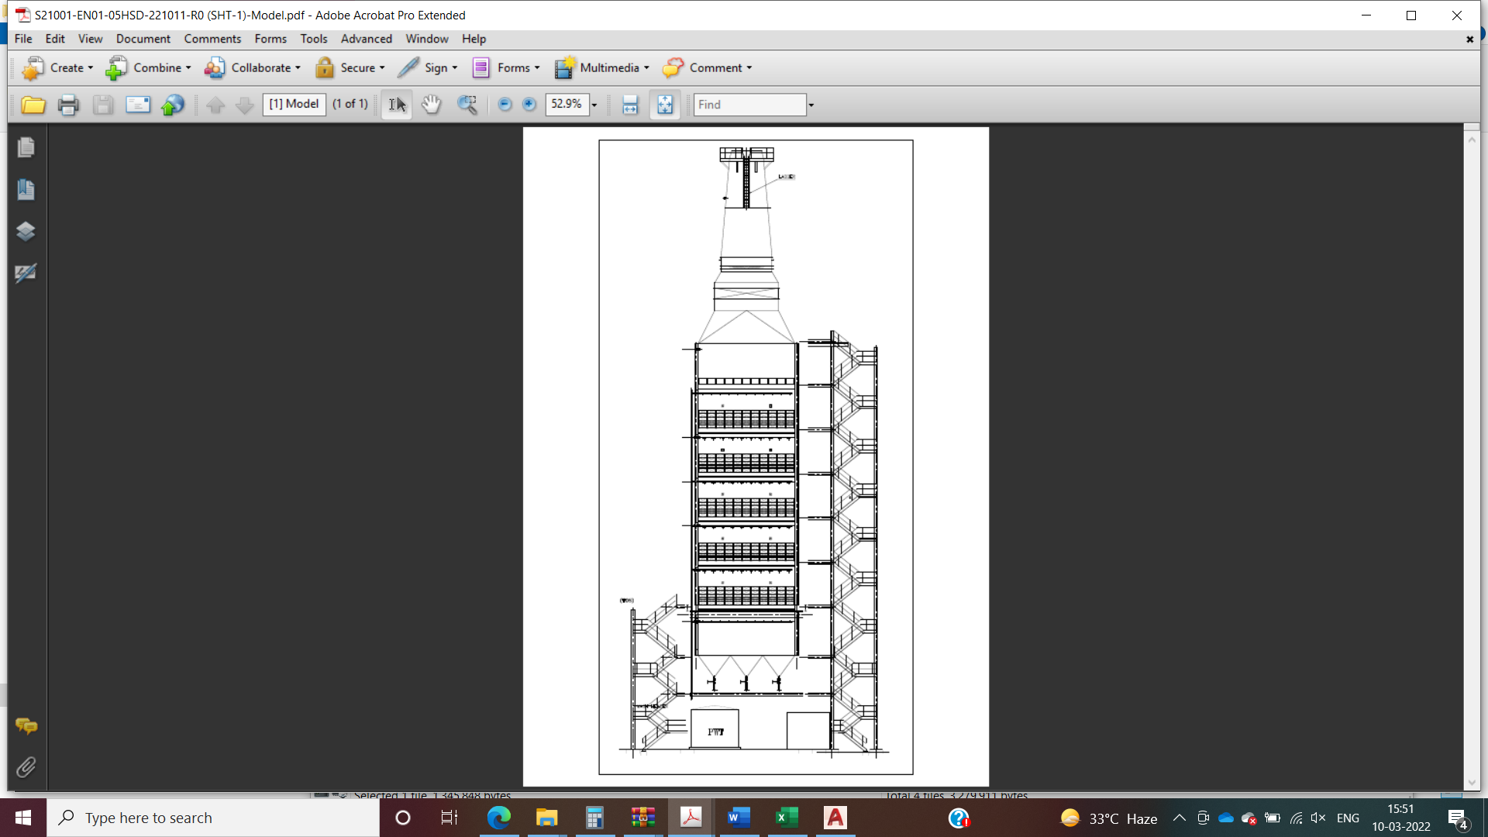
MCU (Mist Cooling Unit)
TYPICAL FGTR & WET STACK

The centrifugal booster fan of the unit will discharge the total flue gas to the Mist Cooling Unit (MCU) where the flue gas will be conditioned by spray water cooling to a saturation point with Relative Humidity close to 100% saturation. The gas temperature at the outlet is expected to be at circa 53 °C after the Mist Cooling Unit. After the Mist Cooling Unit (MCU), the saturated flue gas will enter the Reactor Tower via flow streamliners for SOx capture.

Mist Cooling Unit | KKS No: 50HTH10AC001
Flue gas vol flow rate to MCU | M³/hr | 566640
Flue gas temp at inlet to MCU | deg C | 148
Temp after MCU | deg C | 53.0
Water required to be added to achieve saturation | M³/hr | 22.0
Blowdown from MCU | M³/hr | 7.00
Water flow required at MCU inlet | M³/hr | 29.0
Margin on Flow | % | 32

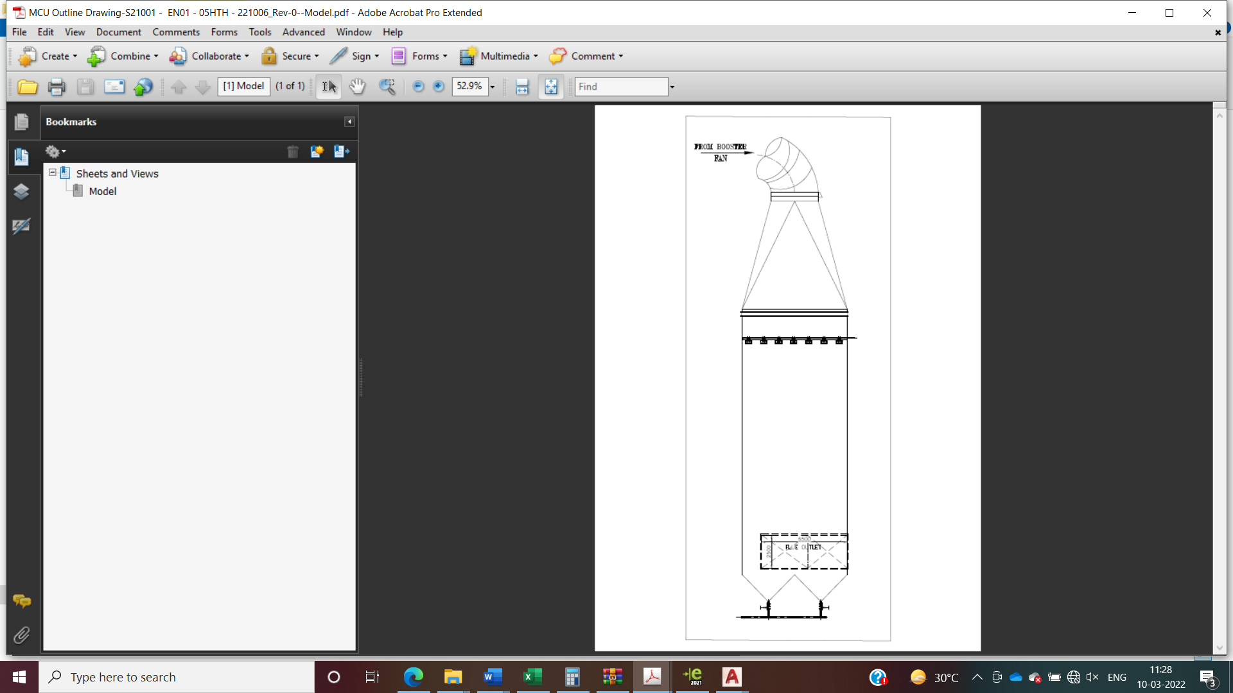

FGD & SAC Plant Process & Storage tanks

PWT (Process Water Tank) tank storage capacity calculation | 50GNK13BB002 |  |  | FWT (Fresh Water Tank) tank storage capacity calculation | 50PBL10BB001
Design Code | IS | 803 |  | Design Code | IS | 803
Media | - | 0.25% H2SO4 |  | Media | - | Fresh Water
Storage volume provided | M³ | 50 |  | Storage volume provided | M³ | 25.00
Diameter considered | m | ~4.50 |  | Diameter considered | m | ~3.00
Height calculated | m | ~3.90 |  | Height calculated | m | ~3.90
Height provided | m | ~3.60 |  | Height provided | m | ~3.60
FGTR Effluent Storage tank capacity calculation | 50HSM34BB004 |  |  | SAC Recovered Water Tank storage capacity calculation | 50GNE10BB005
Design Code | IS | 803 |  | Design Code | IS | 803
Media | - | 10% H2SO4 |  | Media | - | 0.25% H2SO4
Storage volume provided | M³ | 50.00 |  | Storage volume provided | M³ | 50.00
Diameter considered | m | ~4.50 |  | Diameter considered | m | ~4.50
Height calculated | m | ~3.90 |  | Height calculated | m | ~3.90
Height provided | m | ~3.60 |  | Height provided | m | ~3.60
95% H2SO4 STORAGE Tank capacity calculation | 50GNE20BB006 |  |  | Overhead Emergency Tank | 50PBL20BB003
Design Code | IS | 803 |  | Design Code | IS | 803
Media | - | 95% H2SO4 |  | Media | - | Fresh Water
Storage volume provided | M³ | 50.00 |  | Storage volume provided | M³ | 5
Diameter considered | m | ~4.50 |  | Diameter considered | m | ~2.00
Height calculated | m | ~3.90 |  | Height calculated | m | ~2.00
Height provided | m | ~3.60 |  | Height provided | m | ~2.60

FGD & SAC Plant Process & Storage Pumps

Fresh water Pump | 50PBL11AP003 |  |  | FGTR EFFLUENT Transfer Pump | 50HSM21AP009
Fresh water Pump | 50PBL12AP004 |  |  | FGTR EFFLUENT Transfer Pump | 50HSM22AP010
Pump capacity calculated | M³/hr | 40 |  | Pump capacity calculated | M³/hr | 12
Flow | M³/hr | 36 |  | Flow | M³/hr | 4.81
Head | mmWC | 65 |  | Head | mmWC | 50
Process water Pump | 50GNK14AP001 |  |  | PUMP TO CLIENT Services | 50GNK11AP010
Process water Pump | 50GNK15AP002 |  |  | PUMP TO CLIENT Services | 50GNK12AP011
Pump capacity calculated | M³/hr | 36 |  | Pump capacity calculated | M³/hr | 15
Flow | M³/hr | 29 |  | Flow- Continuous | M³/hr | 7
Head | mmWC | 160 |  | Flow- Intermittent | M³/hr | 14.1
FGTR Module Wash Pump | 50HSM11AP005 |  |  | Head | mmWC | 35
FGTR Module Wash Pump | 50HSM12AP006
Pump capacity calculated | M³/hr | 100
Flow | M³/hr | 71.5-91.3
Head | mmWC | 70

